**Heart Disease Machine Learning Algorithm**

UCI Heart Disease Data Set

**EXTRACT**

This data set originates from the University Cleveland .

The data set was sourced through Kaggle.com

Patient metrics including Age, Sex, Chest Pain Type, Resting Blood Pressure, Cholesterol, and Fasting Blood Pressure were identified as the most relevant predictors of positive/negative diagnoses.

The data set includes a binary [Outcome] data point which represents diagnosis of positive/negative.

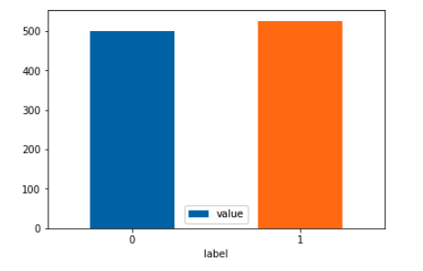

**TRANSFORM**

The data set, (1025 Rows x 14 Columns) was split, trained on 70% of the data, and tested on 30%.

Using the Tensor Flow library, the data was trained, tested, scaled, and encoded.

The model was then fit and the algorithm allowed to i7terate through the data.

**LOAD**

Keras and Sklearn were used to build the model.

The Machine Learning Algorithm is able to iterate through all 13 of the columns to determine the individual weights of each bias.

The Algorithm was able to successfully predict the result of the [Outcome] column with 100% accuracy after only 75 epochs.

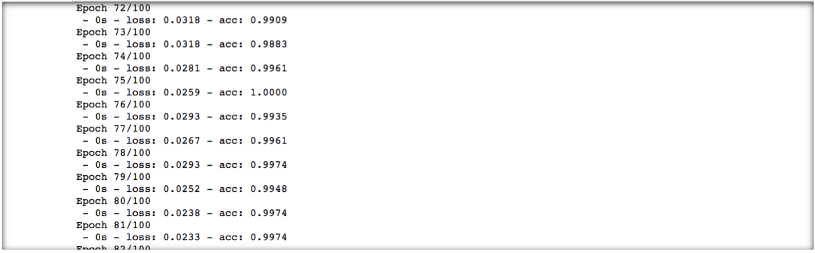

The Algorithm went on to return 8 more results with 100% accuracy and its final 5 attempts all returned predictions with perfect accuracy.

